1. Example: GotFocus
2. Example: MessageBox
3. Example: Simple Random Example – RollDice
4. Example: Check if a number
5. Exercise: Random Exercise – Bigger Smaller Game

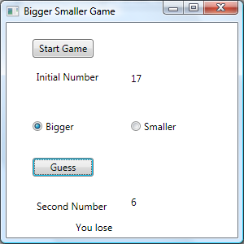Build a game which generates a random number between 1 and 20 inclusive. Display the Initial Number then ask the user to choose if the second number is Bigger or Smaller. When the user then presses Guess another random number is generated. If the user guessed correctly a message is displayed – “you win”, otherwise a “you lose” message is displayed

1. 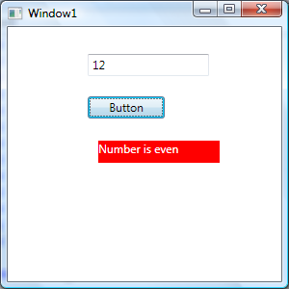Exercise: Odd Even.

Write a WPF app with a single TextBlock and Button. When the user enters a number and clicks the Button, a message appears beneath to indicate whether the number is odd or even. Try to make the program work (and not crash) if nothing is entered (and the Button clicked) or something other than a number is entered. Try varying the colour in response to the odd or even state e.g. green for even and red for odd. Hint: Change the foreground property of the TextBlock

1. Exercise: Come up with your own simple program which uses a simple GUI and makes use of a button, textbox, textfield and has some programming. Be prepared to demonstrate this in class.